
LINCOLN SPORT PARACHUTE CLUB (LSPC)
Landing Out Policy and Procedures
Purpose
The purpose of this policy is to establish procedures and expectations for Lincoln Sport Parachute Club (LSPC) members, students and visiting jumpers in the event of landing outside the designated drop zone (“landing out”). The primary objective is to protect the safety of the skydiver, the public, and property owners while maintaining positive relationships with the surrounding community.
General Policy
Jumpers prefer to land in the planned landing area at the drop zone. However, circumstances such as spotting error, unexpected wind conditions, inadvertent high opening in strong upper winds, or low opening (especially under a reserve canopy) may make landing in the intended area difficult or impossible.
Skydivers at LSPC are expected to take reasonable precautions to mitigate the risk of landing out.
Landing outside the drop zone should occur only in the interest of safety to avoid injury and preserve life.
Preventing Landing Out
- Exit Point Awareness
Jumpers must know the correct exit point for the current weather and wind conditions prior to boarding the aircraft.
- Spot Check at the Door
Once at the aircraft door, jumpers must visually check the spot before exiting. If the spot appears unsafe or incorrect, jumpers should request a go-around from the pilot.
- Freefall Awareness
During freefall, jumpers should check the spot shortly after exit. If necessary and safe to do so, opening altitude may be adjusted. Jumpers must always consider the position of other groups or individuals in freefall when making such decisions.
- Canopy Decision Making
Under canopy, jumpers should continuously evaluate whether the drop zone remains reachable. If it becomes clear the drop zone cannot be safely reached, the jumper should immediately begin selecting an alternate safe landing area.
- Student Jumps
All student skydivers will receive a thorough pre-jump canopy briefing before every jump from their instructor prior to boarding the aircraft. This briefing will include current weather conditions, wind direction and strength, landing patterns, and designated landing areas.
Conduct When Landing Off the Drop Zone
If a skydiver lands outside the drop zone, they must respect surrounding property and landowners.
Jumpers must follow these guidelines:
• Do not disturb livestock.
• Leave all gates exactly as they were found.
• Avoid walking through crops or cultivated vegetation whenever possible.
• Be respectful and courteous to landowners or residents encountered.

Damage to Property
If any property damage occurs, it must be reported to an LSPC board member as soon as possible.
The LSPC board will notify the property owner and make arrangements for repair or compensation if necessary.
Fence Safety
Jumpers must not attempt to cross barbed wire fences.
Do not cut, damage, or climb fences.
Instead, walk along the fence line until the nearest gate or exit point is located and use that access point to leave the property.
Equipment Retrieval
If parachute equipment lands in an area that cannot be safely accessed or is located on private property where permission is required, the local Sheriff’s Office should be contacted.
The Sheriff’s Office can assist by contacting the landowner and coordinating safe retrieval of equipment.
Insurance Coverage
Members of the United States Parachute Association (USPA) are covered by third party insurance that may apply to incidents involving off-field landings.
Insurance inquiries should be directed at:
Kimmel Aviation Insurance Agency, Inc.
442 Airport Road
Greenwood, MS 38930
Contact: Susan Amey
Email: Susan.Amey@Kimmelinsurance.com
Phone: (301) 526-3282, (800) 647-9397

Responsibility
All LSPC members, students and visiting jumpers are expected to understand and comply with this policy. Safe skydiving practices and respectful conduct when interacting with surrounding landowners are essential to maintaining the continued operation and reputation of the Lincoln Sport Parachute Club.

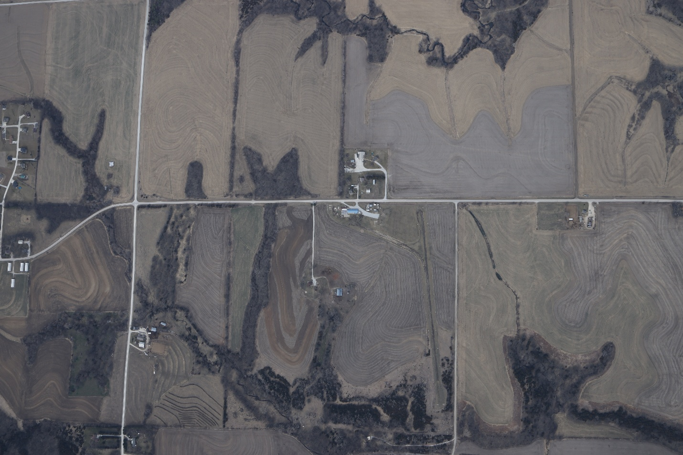

GREEN – Main landing area. All licenses and students. Landing on runway and taxiway is permitted.
BLUE – D license and Tandem ONLY.
Orange – Do not land in or enter this area. Emergency landings only.
Red – Five wire barbed wire fence. Do not attempt to cross fence.

All other surrounding fields are acceptable landing areas for an off landing. Please continue to respect all property and grounds while exiting.

